Exercise 1: Implementing the Singleton Pattern
Design Patterns and Principles – Week 1

Scenario
A logging utility class is needed in the application, and it must have only one instance throughout the application's lifecycle. This ensures that every part of the application writes logs through the same object, keeping the log output consistent and centralized instead of scattered across multiple Logger objects.

Objective
- Create a Logger class that follows the Singleton design pattern.
- Ensure the constructor is private so no other class can create a new Logger object directly.
- Provide a public static method that returns the single shared instance.
- Write a test class to prove that only one instance of Logger exists and is used everywhere.

Approach
The Singleton pattern is implemented using a private static field that holds the only instance of the class. The constructor is marked private, which prevents any external class from instantiating Logger using the 'new' keyword. A public static method, getInstance(), is provided — it creates the instance the first time it is called (lazy initialization) and returns the same instance on every subsequent call.
The instance field is marked 'volatile' and the creation is wrapped in a synchronized block using double-checked locking. This makes the implementation thread-safe, so even if multiple threads call getInstance() at the same time, only one Logger object is ever created.

Class Design
- Logger — the Singleton class. Holds a private static instance, a private constructor, and a public log() method to write messages.
- SingletonTest — the test/demo class that calls Logger.getInstance() multiple times and verifies the same object is returned each time.

Code: Logger.java
package com.example.singleton;

import java.text.SimpleDateFormat;
import java.util.Date;

public class Logger {

private static volatile Logger instance;
private int logCount;
private SimpleDateFormat dateFormat = new SimpleDateFormat("yyyy-MM-dd HH:mm:ss");

private Logger() {
System.out.println("Logger instance created -> " + this.hashCode());
}

public static Logger getInstance() {
if (instance == null) {
synchronized (Logger.class) {
if (instance == null) {
instance = new Logger();
}
}
}
return instance;
}

public void log(String message) {
logCount++;
String time = dateFormat.format(new Date());
System.out.println("[" + time + "] Log #" + logCount + " -> " + message);
}

public int getLogCount() {
return logCount;
}
}

Code: SingletonTest.java
package com.example.singleton;

public class SingletonTest {

public static void main(String[] args) {

System.out.println("---- Getting first Logger object ----");
Logger logger1 = Logger.getInstance();
logger1.log("App started");

System.out.println("\n---- Getting second Logger object ----");
Logger logger2 = Logger.getInstance();
logger2.log("Second call to logger");

System.out.println("\n---- Checking if both are same instance ----");
System.out.println("logger1 hashcode: " + logger1.hashCode());
System.out.println("logger2 hashcode: " + logger2.hashCode());

if (logger1 == logger2) {
System.out.println("Success! Both references point to the same Logger object.");
} else {
System.out.println("Something is wrong, two different objects were created.");
}

System.out.println("\nTotal logs made so far: " + logger1.getLogCount());

logger1.log("One more log to confirm shared state");
System.out.println("Now logger2 also shows updated count: " + logger2.getLogCount());
}
}

Output
Running SingletonTest.main() produces the following output. Notice that the line "Logger instance created" is printed only once, even though getInstance() is called twice — this confirms that only a single Logger object is created. Both logger1 and logger2 also show the exact same hashcode, and the log count is shared between them since they refer to the same object.
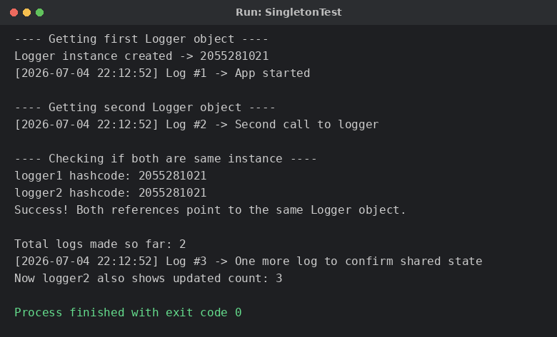

Conclusion
The Logger class successfully follows the Singleton design pattern. The private constructor blocks direct instantiation, and getInstance() guarantees that only one object is created and shared across the entire application. The test class confirms this by showing that two references (logger1 and logger2) point to the exact same object in memory, and that the shared log counter increases consistently regardless of which reference is used to call log().

